Accessing Your Ballot
All judges are Linked in, which means you should have received an email from Speechwire with a password in it. It might have gotten caught in a junk filter. But it would have looked like this:
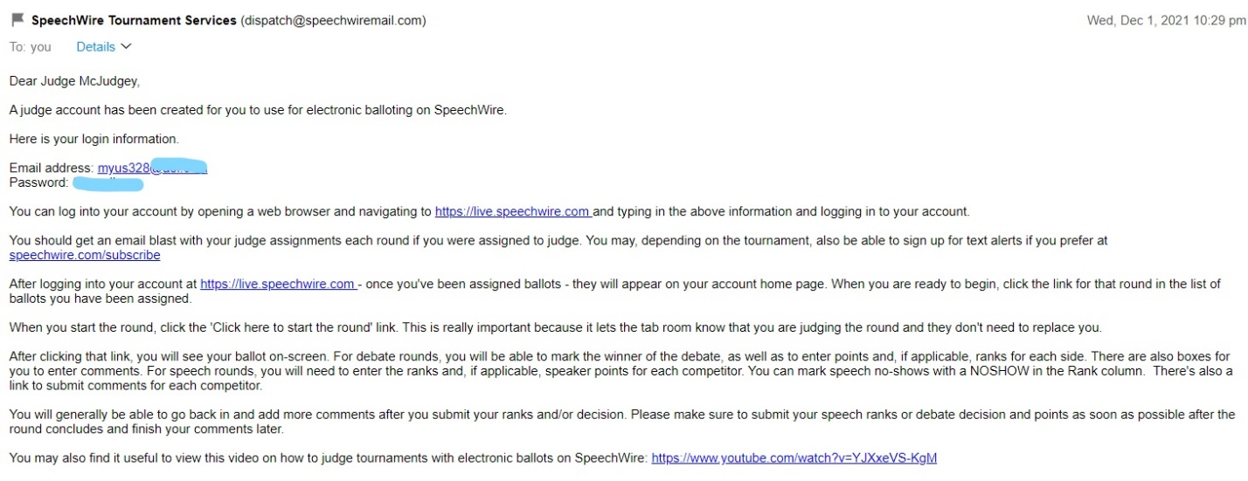
Once you retrieve your password from the Speechwire email, go to https://live.speechwire.com/. There is a space for email address and the password sent to you from the Speechwire message you should have received earlier this week. You do not need to create an account!!
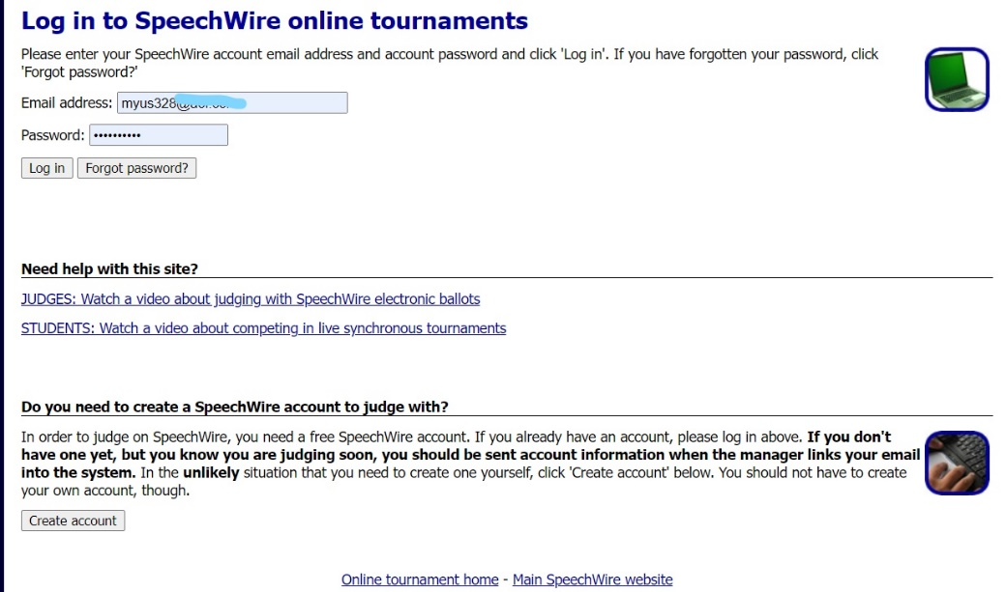

Once you are signed, you will be sent to a page that lists the rounds you have to judge. This judge does not have any assignments, but they would be on a page that looks like this:

When there is a ballot, all you have to do is click on the link and then hit “START ROUND” as soon as you can!! That is SUPER IMPORTANT!! It is our only way of knowing if you are there so we can pay you for your time. Ballots will be sent out every hour or so. George’s will have free food and seating both Saturday and Sunday.
RUNNING THE ROUND
BEFORE THE ROUND
- Remember, any questions you may have, you can email gmujudges@gmail.com at any point in the tournament and we will help you any way we can!! On Saturday, you will be the only judge in the room and you will have to “Run the Round”. Think of it like speech day in your COMM 101 class. Its your turn to play teacher!! On Sunday, once we get to quarter-finals, semi-finals, and finals, there will be 3-5 judges each round.
- Every hour, we will send out an email to everyone who has been assigned a round. We have a computer that makes assignments randomly. If we have not contacted you, it means you are on “Standby”. Just like flying, we ask that you remain available to pick up a round if we send you a text message. We try to make sure people have time off to eat and study.
- Keep in mind speakers might come in a different order than is listed on your ballot. Many students are in multiple events, meaning they will try to perform different speeches throughout the hour. If and when these changes occur, please be flexible and make sure you don’t mix around names and ranks. Lastly, students might get lost on the way to your room because for some, this is their first time on a college campus. Please be accommodating of that fact and wait until every student have spoken before turning in your ballot. Each round lasts an hour and fifteen minutes. If you are still waiting at the end of that time, email gmujudges@gmail.com and we will tell you the next step

JUDGING THE ROUND
- Start the round by asking for students names and if they have other events this round. If someone says they have 3 events to do, let them go first. People who have two events should go next. Some students will only have your event, and they should stay and watch. You will say the name of the performer you want to see.
- Extemp and Impromptu require time signals be given. Details for those are on the Event descriptions we sent you. If you have any one observing the round, you can also ask them to give time signals, if they are comfortable with doing so.
- You can click on someone’s name to “open” their ballot. We ask that you write at least 2 comments of things that you saw that you liked, and then two comments of things that didn’t make sense or they could improve on. How was their delivery, eye contact, facial expressions, and movement? Could you understand what they were talking about? Did the delivery match what was being said? We are sending you the event descriptions for more details. But you have a chance to educate a student and every comment helps. Not writing anything hurts the students. They don’t need experts; they just need someone to listen.
AFTER THE ROUND
- Once all the competitors have performed, say thank you and tell the round they are free to leave. Then, we ask that you rank the round. In Speech rounds, this is the page that has all the competitor names on it. The person who did the best should be ranked first, the next best would get your second, etc. You may give multiple 5’s in prelims. They will also ask for Speaker Points or Ratings. This is out of 100 points. Think of these like grades. Most will fall between 100-85. 90-100 points should be given to those who are generally good speakers and engaging. 80-90 should be reserved for people who seem very unprepared. If you someone gives up or offends you, email gmujudges@gmail.com and we will give you options as to what you should do. In debate (Public Forum or Lincoln-Douglas), you will pick a winner (Aff or Neg – don’t worry, they will tell you who is who) and then give Speaker Points or Ratings out of 30. Again, most fall between 20-30. Below 20 means they really did something wrong or offensive.
- Come back to Georges for food or to wait for the round to be sent out.

